LinkedIn Network Connection Analysis — Project Report

Project Overview
Project Title: LinkedIn Connection Analysis and Visualization
Objective: To process LinkedIn student data, clean and normalize it, construct a connection graph, and analyse relationships via random walk paths and statistics.
Data Source
Raw LinkedIn CSV/Excel files containing student names, company associations, and connection data.
Data Cleaning & Preprocessing
Highlights:
- Applied standardized file renaming.
- Detected encodings (UTF-8, ISO-8859-1, etc.) with fallback support.
- Cleaned duplicates, special characters, whitespace, and formatted all text (title case).
- Skipped corrupt or empty files post-cleaning.
Graph Construction
Highlights:
- Built an adjacency list connecting students based on shared company associations.
- Computed node degrees to find hubs and isolates.
Random Walks & Path Analysis
Highlights:
- Generated multiple random walks between student pairs.
- Applied pruning to keep shortest, loop-free paths.
- Calculated average, median, mode of path lengths.
- Visual Comparison of Walk vs Pruned Paths -
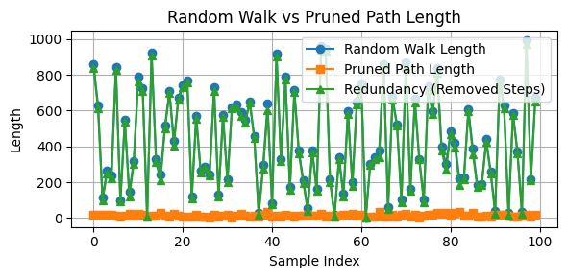
Key Observations
- Pruned paths ranged mostly between 10 to 20 hops, with a few longer exceptions.
- A small number of students had high connectivity (network hubs).
- Major column header inconsistencies across datasets.
- Manual checks confirmed effective cleaning and path logic.
Summary Statistics
- Total Files: 130
- Cleaned: 127 | Skipped (Corrupt): 3
- Unique Header Patterns: 14
- Adjacency Lists Created for over 26927 unique students.
- Degree Computation performed for each of these nodes to assess individual connectivity.
- Generated 100 Random Walk paths and corresponding Pruned Shortest Paths between student pairs to analyse graph traversal behaviour and connectivity structure.

